**IDX G9 MATH S STUDY GUIDE ISSUE 1**

**By Aeson**

(This is made to follow through with the packet/Classwork Book)

**Chapters** *(Following in the order of the Classwork Book)* :

1. **Sets & Venn Diagrams**

* Sets
* Intersection and Union
* Complements
* Number Sets
* Interval Notation
* Venn Diagrams

1. **Patterns and Inductive Reasoning** *(Ch 1.1)*
2. **Logic Statements**

* Conditional Statements *(Ch 2.1)*
* Biconditionals and Definitions*(Ch 2.2)*
* Inverses, Contrapositives, and Indirect Reasoning *(Ch 5.4)*

1. **Deductive Reasoning** *(Ch 2.3)*
2. **Geometry Elements**

* Points, Lines, and Planes *(Ch 1.3)*
* Segments, Rays, Parallel Lines and Planes
* Measuring Segments
* Measuring Angles
* Reasoning in Algebra

1. **Intersecting and Parallel Lines**

* Proving Angles Congruent
* Properties of Parallel Lines
* Proving Lines Parallel

**-Sets-**

**1) Sets:**

* Collection of numbers/objects
* 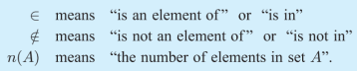There are different notations for sets:
* They are written as: {2, 3, 5, 7, 11, 13, 17, 19}

**Definitions:**

* Two sets are **equal** if they contain the same elements
* A **subset** is if every element of Set A is also an element of Set B.
* 
* A **proper subset** is when a subset doesn’t include the fact that A = B.
* An **empty set** is just: { }. A set that contains NO elements.
* Sets are **finite sets** if n(A) has a definite value. Where if it has an endless amount, then it’s an **infinite set.**

**2) Intersection:**

* The **intersection** of two sets A & B is the elements that are BOTH in A and B.
* {1, 2, 3, 4, 5, 6, 7} intersect {2, 3, 5, 7, 9, 11} = {2, 3, 5, 7}

**Union**

* The **union** of two sets A & B is basically counting all the elements in both sets.
* {1, 2, 3} union {4, 5, 6} = {1, 2, 3, 4, 5, 6}

**3) Complement of a Set:**

* A **universal set** (U) is the set of all elements.
* The **complement** of a set is the universal set excluding the set that it’s a complement of.
* Example: U = {1, 2, 3, 4, 5} and A = {2, 3, 5}, then A’ = {1, 4}

**4) Number Sets:**











-

**5) Interval Notation:**

* Another way to describe a set on a number line.



**Bracket Notation:**

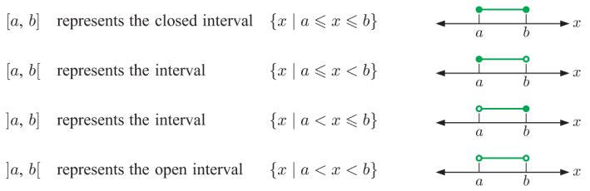

* **And on an important note:**

**-Patterns & Inductive Reasoning-**

**Inductive Reasoning:**

* Based on patterns you observe, you can use **inductive reasoning** to tell what the next sequence is.
* A conclusion you reach using inductive reasoning is called a **conjecture**.
* An example for which the conjecture is incorrect is a **counterexample**.



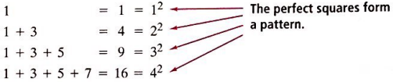

**Logic Statements**

1. **Conditional Statements**

* An if-then statement is a **conditional**. The part after “if” is the **hypothesis**, and the part after “then” is the **conclusion**.

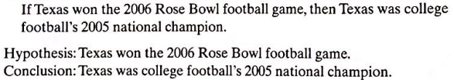

* A conditional has **truth values** which are *true or false*. Based on their hypothesis, you can tell they are true, or are false. (You have to provide a *counterexample* if it’s false).
* The converse just switches up the hypothesis and conclusion.

**Conditional: If two angles have the same measure, then the angles are congruent.**

**Converse: If two angles are congruent, then the angles have the same measure.**

**Biconditionals: Two angles are congruent if and only if they have the same measure.**

1. **Biconditionals and Definitions**

* When a conditional and it’s converse are both true, you can combine them as a **biconditional**. Connecting a hypothesis and it’s conclusion with “if and only if”.

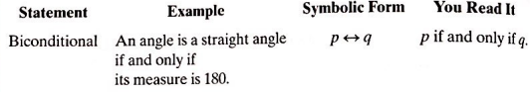

1. **Inverses and Contrapositives**

* The **negation** of a statement has the opposite truth value.
* The **inverse** of a conditional statement negates both the hypothesis and conclusion.
* A **contrapositive** is just a converse statement, but both hypothesis and conclusion are negated.

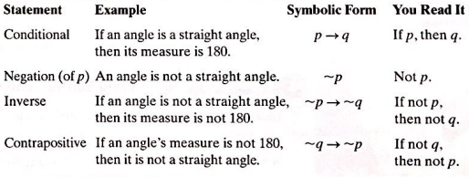

1. **Indirect Reasoning**

* All possibilities are considered, and only one is proved false. Which is **indirect proof**.

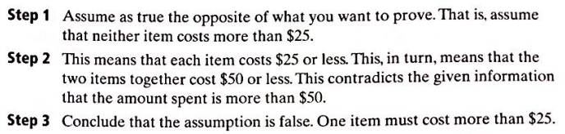

**Deductive Reasoning**

**Deductive Reasoning:**

* The process of reasoning logically from give statements to a conclusion. If the given statements are true, then it will always produce a true conclusion.
* **Law of Detachment: If a conditional is true and its hypothesis is true, then its conclusion is true.**

**A WRONG Statement:**

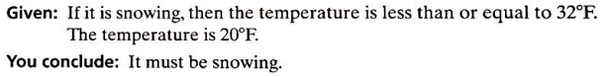

* **Law of Syllogism: Allows you to state a conclusion from two true conditional statements when the conclusion of one statement is the hypothesis of the other statement.**

**A CORRECT Statement:**

If a number ends in 0, then it’s divisible by 10.

If a number is divisible by 10, then it’s divisible by 5.

**Conclusion: If a number ends in 0, then it’s divisible by 5.**

**Geometrical Elements**

1. **Points, Lines, and Planes**

* **Point**: A location. It has no size, and it is represented by a dot and a capital letter naming it.
* **Line**: A series of points that extends in two opposite directions with no end. You can name this with any two points on the line.
* **Collinear Points**: Points that are on the same line.
* **Plane:** Flat surface with no thickness. It extends for eternity, containing many lines and points.
* **Coplanar:** Points and Lines that are on the same plane.

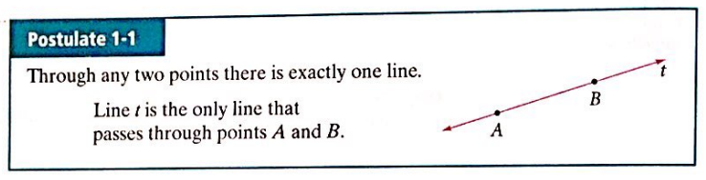

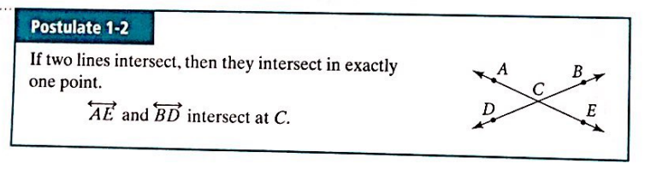

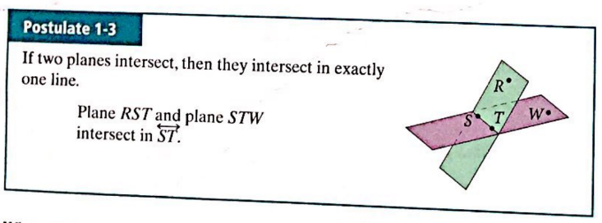

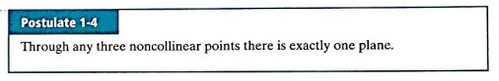

1. **Segments, Rays, Parallel Lines and Planes**

* 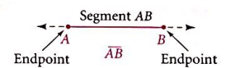**Segment:** Part of a line, consisting of two endpoints and all points between them.
* 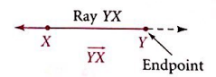**Ray:** Part of a line consisting of one endpoint and all points on the one side of the endpoint.
* **Opposite Rays:** Two collinear rays with the same endpoint. They ALWAYS form a 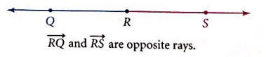line.
* **Parallel Lines:** Coplanar lines that do not intersect.
* **Skew Lines:** These are noncoplanar. They don’t intersect and are not parallel.
* **Parallel Planes:** Planes that don’t intersect.

1. **Measuring Angles**

* **Angle:** Two rays with the same endpoint.

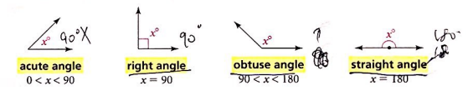

* **Congruent Angle:** Angles with the same measure

1. **Reasoning in Algebra**